AWS Building a Static Website

Adhvitha Sivaganesh| CCNP

Purpose:

The purpose of this AWS lesson was to learn how to build a static website with simple storage service. I learned how to create an Amazon S3 bucket with specific permissions and enable static website hosting for the Amazon S3 bucket. In this lesson we also learned how to add a bucket policy so that we could make the objects readable in the S3 bucket. Overall, in this lab we learned how to configure an Amazon S3 bucket and set permissions so others can access the website.

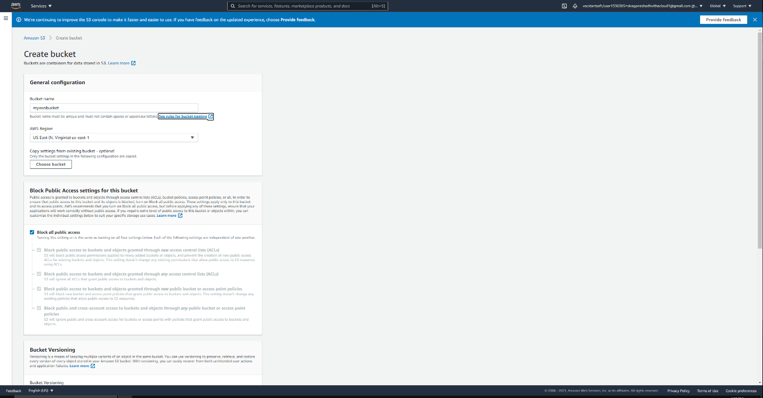

* I went into the Amazon S3 console and went over the bucket limitations and restrictions. I created a bucket called “myccnpawsbucket”

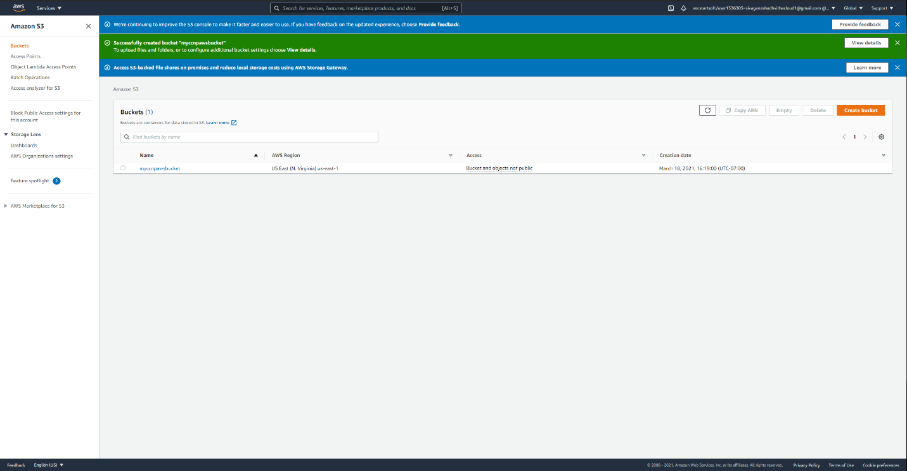

* After creating the bucket, I went back into S3 Console to see the properties and aspects of the bucket I created.

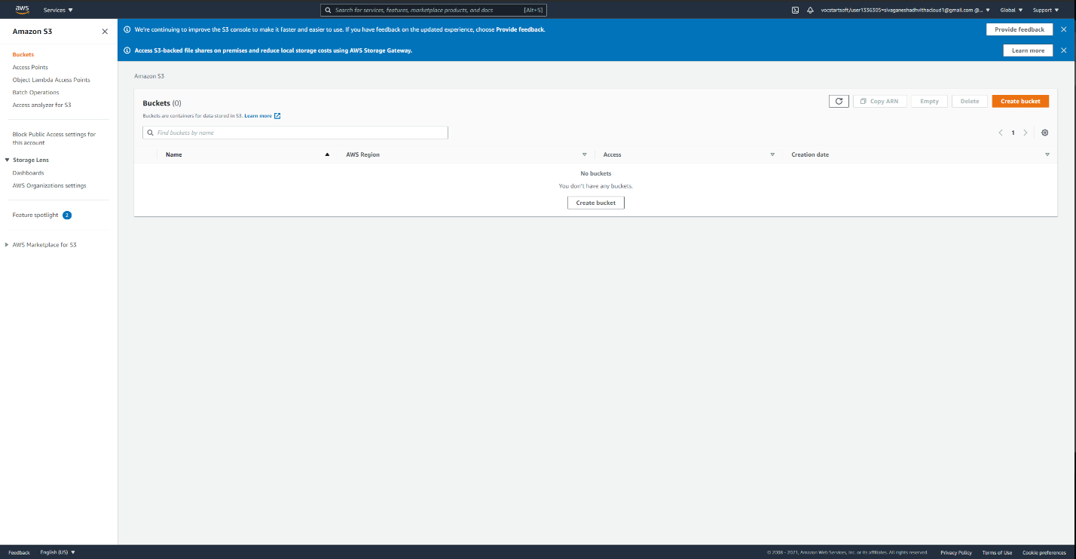

* I selected the bucket and then went into the properties tab to select Static Website Hosting for the bucket.

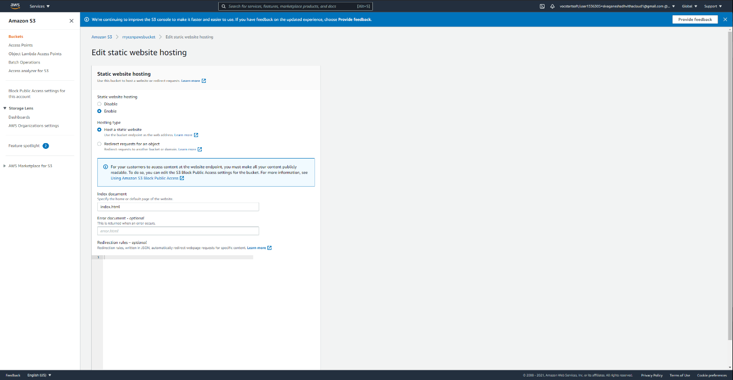

* I entered the name of the index document as index.html and saved my work.

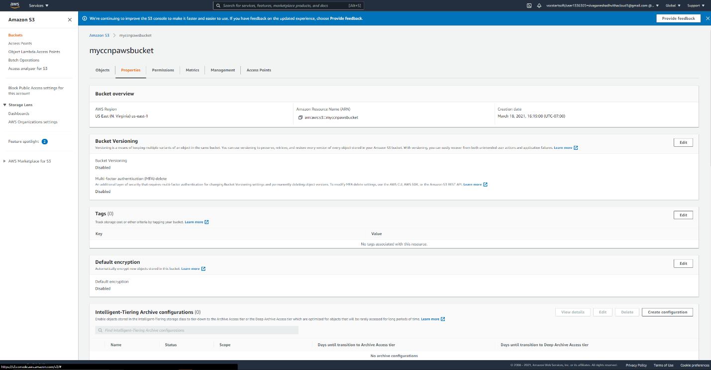

* I went into the bucket I created and saw all of the properties that was a part of it currently.

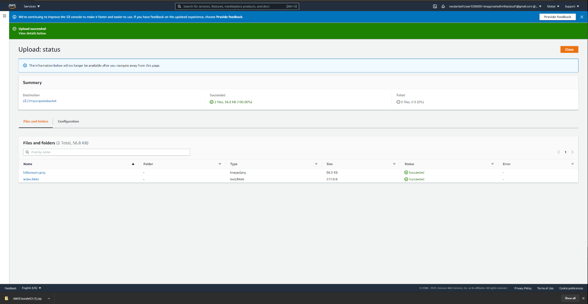

* I downloaded the files that needs to be uploaded to the bucket. After that I specifically uploaded the index.html and bitbangers.png.

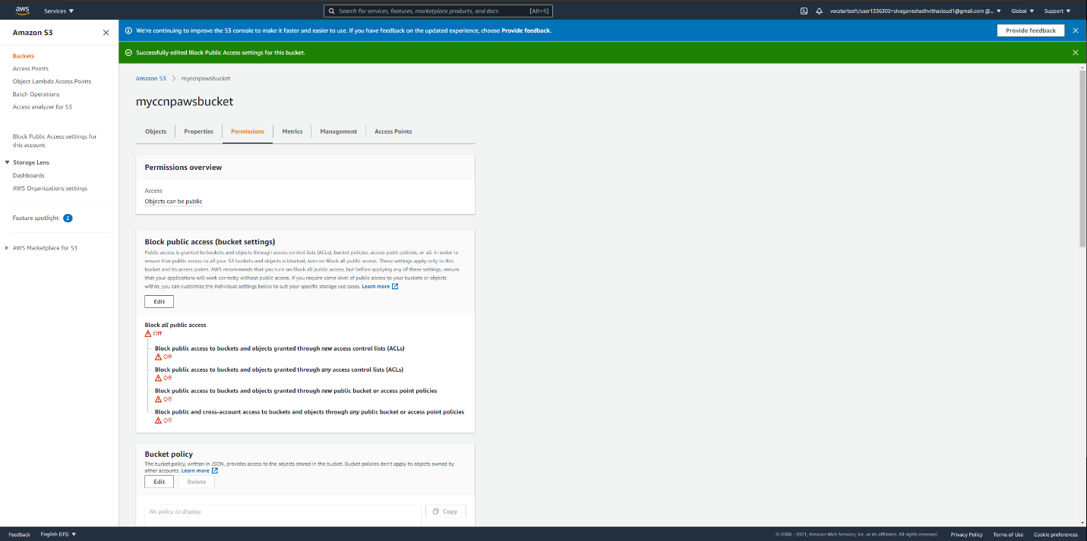

* After that I selected my bucket and went into the permissions tab to block the public access.

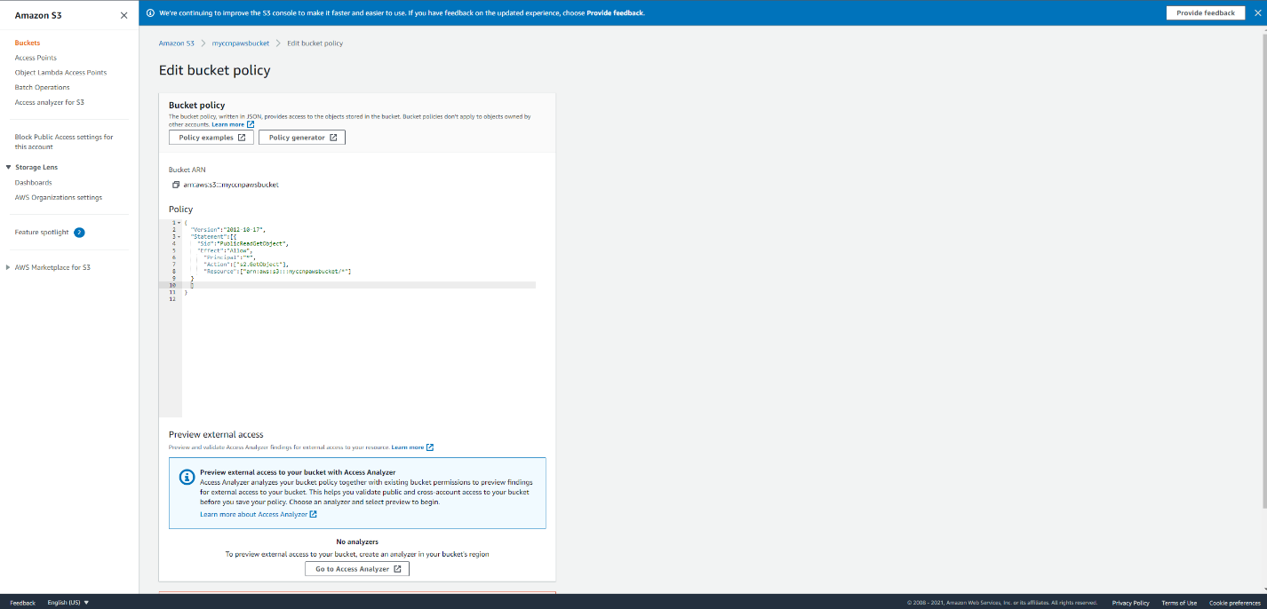

* I went into the bucket policy and edited the policy to match my current bucket and copied what was on the instructions

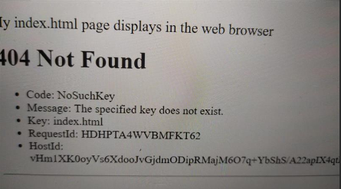

* I put in the URL after saving the policy and that was the result.

Problems:

Some problems that I had included the bucket policy and editing it. I realized just copying and pasting the code is not enough. I kept double checking, and everything seemed right and after I asked some friends they mentioned that even the spaces and indents matter. I redid the code afterwards and then there was no error, so I was able to save my edited bucket policy.